Copyright reserved

Please turn over

**NATIONAL CERTIFICATE**

**INDUSTRIAL INSTRUMENTS N5**

**22**

**April 2021**

**This marking guideline consists of 6 pages.**



**MARKING GUIDELINE**

**SECTION A**

# QUESTION 1

1.1 There is a negligible effect on the calibration of the flowmeter with changes in liquid conductivity.✓ A common misunderstanding of magnetic flowmeters pertains to the relationship between liquid conductivity and magnetic flowmeter calibration.✓ As long as the conductivity stays within the acceptable range for the meter,✓ changes in conductivity have a negligible effect on calibration.✓ The voltage-measuring circuit of the flowmeter has such vastly greater impedance than the electrical path through the liquid✓ that any changes in liquid conductivity are swamped by the much greater input impedance of the

meter.✓ (6)

1.2 • Potential energy: A body of mass (m) at a height (h) above the ground possesses a potential energy of mgh.

* Kinetic energy: This is the energy arising from motion and for a particle of mass (m) moving with a velocity (v) it is ½mv2.
* Internal energy: In a thermodynamic system, the difference between the energy supplied to the system and the energy supplied by the system is considered as its internal energy (I) or the energy due to the temperature of the fluid.✓
* Pressure energy: This is the energy arising from pressure (p) and a specific

volume (v), thus PV. (4 × 2) (8)

1.3 If a liquid, of which the flow rate must be measured, flows into a restriction, a differential pressure will be setup.✓ This differential pressure varies as a square root of the flow rate.✓ This means that the flow rate (Q) is not linear to the differential pressure (h) which is measured.✓ According to Bernoulli

Q = k√ℎ✓ where k = constant. (4)

1.4 An integral orifice cell is miniature flow✓ mounted to a DP cell.✓ It can be used for laboratory scale processes to measure additives to major flow streams✓

and in general for measurement of small fluid flow.✓ (4)

**[22]**

# QUESTION 2

2.1 A: Flow

B: Thermocouple 1 and Thermocouple 2 C: Wattmeter

D: Heater (4 × 1) (4)

2.2 A heat-transfer flowmeter **OR** Hotwire-electrode probe-sensing element for

thermal flow measurement (1)

2.3 Temperature sensors and the heater must protrude into the fluid stream. Thus these components (particularly the heater) are easily damaged by corrosion

and erosion. (2)

2.4 To overcome these limitations, the heater and the upstream and downstream✓ temperature sensors can be mounted on the outside of the pipe wall.✓ (2)

2.5 It measures the rise in temperature of the fluid after a known amount of heat

has been added to it. (2)

**[11]**

**TOTAL SECTION A:**   **33**

**SECTION B**

# QUESTION 3

3.1

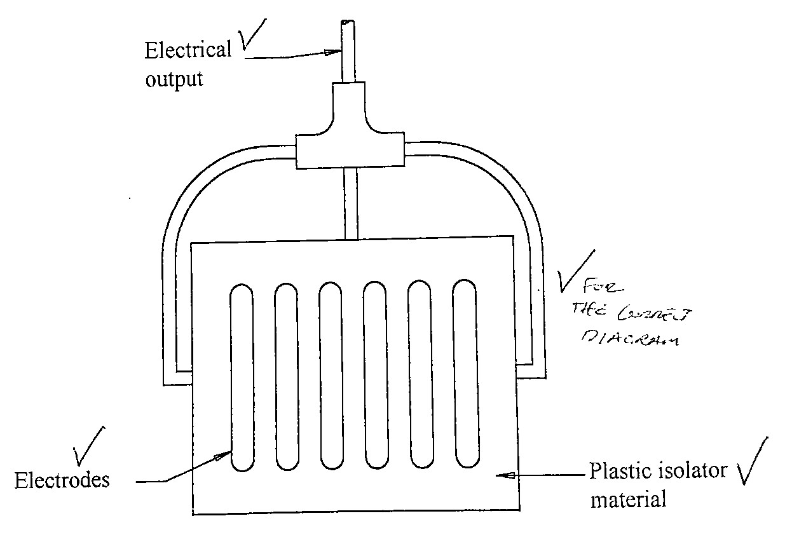

This instrument consists of stainless steel electrodes mounted on a plastic isolator.✓ These electrodes form the capacitor✓ and the dielectricum will be influenced by the amount of vapour present in the substance being measured.✓ The change in capacitance can be measured by a capacitor

Wheatstone bridge or a LC resonant circuit.✓ (8)

3.2 The meter displaces a volume of the unknown liquid✓ until an equilibrium is reached between an upward buoyant force and a downward hydrometer force.✓ By suitable graduation, calibration with known fluids and the addition of lead-pellet weights,✓ the scale beading is calibrated to read either specific

gravity or some related unit.✓ (4)

3.3 • Temperature

* Pressure
* Flow composition (density) (3)

3.4 3.4.1 Normally a sampling system is not required on a gas sample.✓

Liquid sample temperature must be held constant.✓ (2)

3.4.2 The instrument can be used on all gases that is not corrosive to the probe✓ or which will not combine spontaneously on contact with the probe materials.✓ With regard to liquids, the instrument is limited to those fluids with a moderate solubility for water vapour,✓ thus the instrument is not suitable for measurement in polar liquids such as

the alcohol.✓ (4)

* 1. Henry's law states that at constant temperature the mass of water vapour dissolved in a given volume of liquid is in direct proportion to the partial pressure of water vapour in the sample.

**OR**

The weight concentration of moisture in a sample is equal to the partial

pressure of water vapour times a constant. (2)

* 1. • Avoid vapour entrainment in the sample liquid due to agitation or boiling.
* Avoid a turbulent environment.
* Calibrate the instrument regularly to ensure accurate measurements.
* Remove gradual material build-up or wear of the piston and tube.
* Clean the measuring unit at regular intervals.
* The size of any undissolved solids in the liquid to be tested should be small enough not to interfere with measurements.
* Know sensitivity requirements for bleeding process applications.
* Avoid using this instrument for liquids with poor flow characteristics.

(Any 5 × 1) (5)

**[28]**

**TOTAL SECTION B:**   **28**

**SECTION C**

# QUESTION 4

4.1 • To maintain speed of response and accuracy of determination, the electrodes should be cleaned periodically.

* The frequency of cleaning and the method are dependent on the nature of the process liquid.
* In general, washing with water and wiping with cotton wool soaked in diluted hydrochloric acid will suffice, but in severe cases the electrodes may require soaking in solvent.
* Inorganic solvents are preferable for removing greasy and oily deposits.
* Alcohol and acetone are commonly used but care must be taken that another deposit just as immiscible is not on the electrode.
* Organic solvents have a dehydrating effect on the membrane and only the brief immersion in the solvent followed by soaking in hydrochloric acid should be employed.
* Electrode cleaning frequency may be considerably reduced by the fitting of an in-site cleaning device.
* One such device provides for a set of solvent to be periodically directed at the electrodes.
* Another technique providing continuous cleaning without the introduction of solvents employs an ultrasonic transducer attached to a thin plate and

operated by a remotely mounted generator. (9)

4.2 4.2.1 Continuous-flow electrode system (1)

4.2.2 A: Removable cover

B: Cover clamp

C: Removable bowl

D: Drain tap

E: Reference electrode

F: Glass electrode (6)

4.3 The electrode must be protected against the magnetic field present. (2)

**[18]**

**TOTAL SECTION B:**   **18**

**SECTION D**

# QUESTION 5

(10)

5.1

OUTPUT

(CURRENT)

Set point value

Measured variable

(current)

Σ

Σ

THREE TERM

ALGORITHM

CURRENT-

VOLTAGE

CONVERTER

(

see section

10.3)

SETPOINT

POTENTIO-

METER

Σ

VOLTAGE-

CURRENT

CONVERT

ER

(

see

section

10.2

-

1

R

F

Kp

TI

TD

set

set

set

Set point

voltage

error voltage

feedback voltage

Offset

voltage

V

offset

voltage

+

-

+

-

+

+

FORWARD/REVERSE

CHANGE OVER

5.2 Proportional action will reduce a steady-state error and increase the step-response overshoot as the proportional band Kp is reduced. Integral action will eliminate a steady-state error arising from most causes and as the integral action time T1 is reduced, the step-response overshoot is increased. It is unlikely to be required whenever the plant process contains an inherent integrating term, since the resulting loop would then contain two integrations. Derivative action will reduce the step-response overshoot as the derivative

action time TD is increased. (5)

(6)

5.3

**[21]**

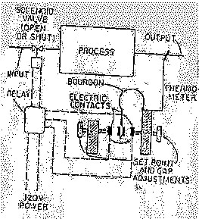

**TOTAL SECTION D:**  **21**

**GRAND TOTAL:** **100**